How-to Guide

You can organize your breakfast any way you want, but here’s what has worked for us:

Gather together:

- A three-ring binder
- Dividers
- Avery T-shirt transfers (#3271)
- Avery labels (whatever works for your mailing list)
- Stationery for your invitations
- Envelopes

The Host’s Kit is designed to assist you in organizing a porridge breakfast. You may want to get a three-ring binder and label dividers with the same topic headings as in the kit. You will likely want to start a Word folder on your computer called “Porridge breakfast” and download these files. (PDF are print only. Word files can be manipulated.)

The downloadable package of files includes the following:

- Generic logo
- Shopping list
- Invitation template
- Silent auction sheet
- Name tag template (for use with Avery #05395 or #08395 label sheets)
- Fruit compote recipe
- The porridge recipe
- What is Porridge for Parkinson’s?
- Why now?
- Apron/T-shirt transfer (for use with Avery # 3271)
- Tent cards 1
- Tent cards 2
- Tent cards 2
- Porridge for Parkinson’s logo (a 300 dpi TIF file)
- This how-to guide

Shopping list

This is self-explanatory. Download and multiply the recipes by your expected number of guests.

Invitation template

This invitation can be printed up on 8 1/2 by 11 inch paper: any grade you want. Don’t panic, the sideways layout is easy to manipulate.

The orientation of the layout is “landscape” format. In order to rotate the text where your invitation details will appear, simply position your cursor over that quadrant and right-click with your mouse. The contextual menu that will appear contains a number of options, including “Text Direction”. With your mouse, left click on Text Direction. This will launch the Text Direction dialog box, which can be seen in fig. 1 below.

fig. 1 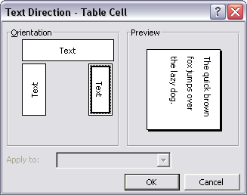

In the Text Direction dialog box, select the horizontal direction for the text, and then click OK. By rotating the text direction you will be able to insert your details into the sample invitation. After inserting your details you will then need to rotate the text back to its original direction, in order for it to work with the folding invitation layout. The final step is to double-check that the text formatting you have chosen still looks OK after rotating back into the final layout. You may want to add some spacing between the lines of text, depending on the formatting you have done.

Upon sending the file to your printer you will be presented with the error message as seen in fig. 2 below. Omit the error by clicking Yes, as the file will print just fine.

fig. 2 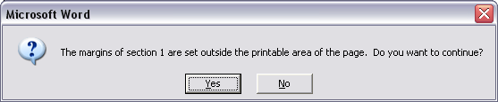

Print your invitations, fold them into four and they will fit a standard invitation size envelope.

Silent auction sheet

There are a number of ways you can do this. Here’s a couple of ideas:

- Download these sheets, run off a bunch and fill them in by hand with the information for each item as it shows up.

- Or, compile a list of donated items on your computer, then transfer each to the top of a silent auction sheet.

Name tag template

Use Avery labels #05395 or #08395, and you can run them through your printer.

Recipes

These are self-explanatory. Some people have printed them up on card stock and sold them as fundraisers.

What is Porridge for Parkinson’s and Why now

You can use these as handouts if you want.

Apron/T-shirt transfer

Using Avery product #3271 print this file onto a transfer. The trick is to be sure to select the mirror image option when you print the transfer. These transfers are handy for aprons, T-shirts, chef’s hats, anything you can think of. We found inexpensive and good quality aprons, chef’s jackets and hats at Alternative Uniform Designs www.altuniform.com.

Tent cards

This collection of quotes about porridge is a sure-fire attention-getter. Print the file on card stock. Cut them in half and place around your venue for conversation starters.

